University at Buffalo
2024 Sexual Harassment Prevention Training Course Instructions
A how to guide to complete your training

Table of Contents
2024 Sexual Harassment Prevention Training Course Instructions 1
Accessing the Course 1
Discovering the Course 3
Continue with the Course 5
Alternative Formats and Accessibility Features: 10
Certificate of Completion 19
Completing Sexual Harassment Prevention Training on Mobile Phones or Tablets -- Accessing UB Learns from your portable device. 27
Android Mobile Phone or Tablet: 27
iPhone Mobile Phone or iPad: 34

2024 Sexual Harassment Prevention Training Course Instructions
Follow the instructions below to complete the online training course via UB Learns
UB Learns Website Link: ublearns.buffalo.edu
*Important note: This course will not work when using the Internet Explorer (IE) internet browser.
Verify that your internet browser is compatible. To use UB Learns, use a computer that is connected to the Internet and the most up-to-date web browser. It is recommended that you use the most current version of:
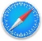
Chrome Safari
Firefox Microsoft Edge
Brightspace technical support offers a list of certified and compatible browsers, listed by Operating System, for use with UB Learns D2L Brightspace Compatible Browsers (UB Learns).
Accessing the Course
- Go to UB Learns, and select “Log in to Brightspace”.
  - Enter your UBIT Name and Password, Click Login.
To look up your UBIT Name, please go to: https://www.buffalo.edu/search/you
- You may be prompted to verify your identity via UB DUO.
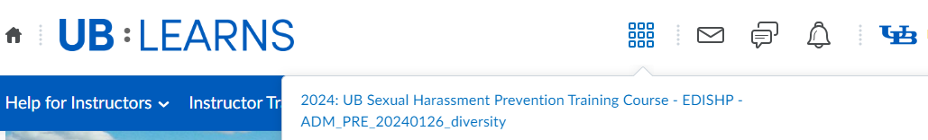
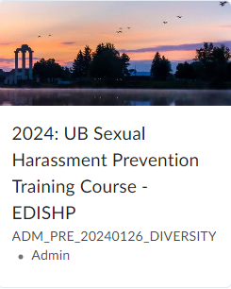
- Begin at ‘Select a Course’, to the right of the UB: Learns icon
From your list, Select 2024: UB Sexual Harassment Prevention Training Course – EDISHP – ADM_PRE_20240126_diversity
You may also access the course in your ‘My Courses’
Widget once you have accessed the course once.
Select the 2024: UB Sexual Harassment Prevention
Training Course – EDISHP in your
‘My Course’ widget.
This will navigate you to the beginning of the course.
Discovering the Course
If you do not see the 2024: UB Sexual Harassment Prevention Training Course – EDISHP in your ‘Select a Course’ pulldown, you will need to:
- Discover the course
- Self-Enroll in the course
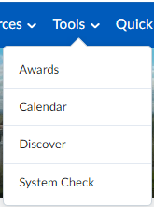
- From the UB Learns homepage, select Tools
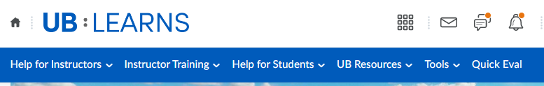
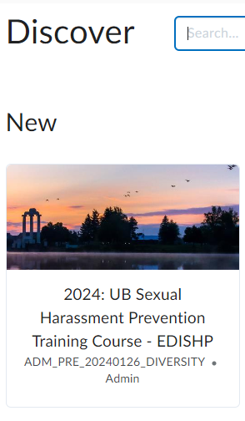
- Select Discover
- Select 2024: UB Sexual Harassment
Prevention Training Course - EDISHP:
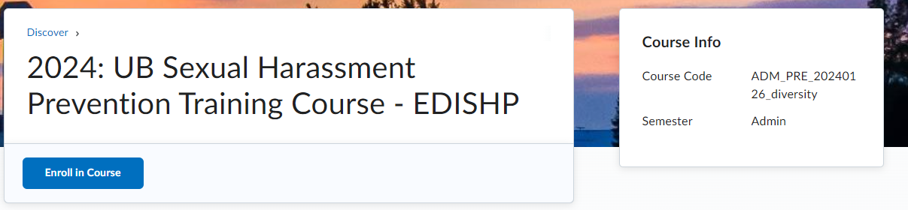
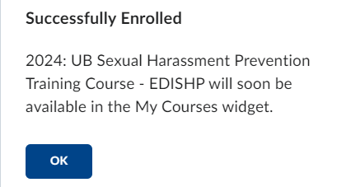
- Select Enroll in Course
- Select OK for Successful Enrollment:
Continue with the Course
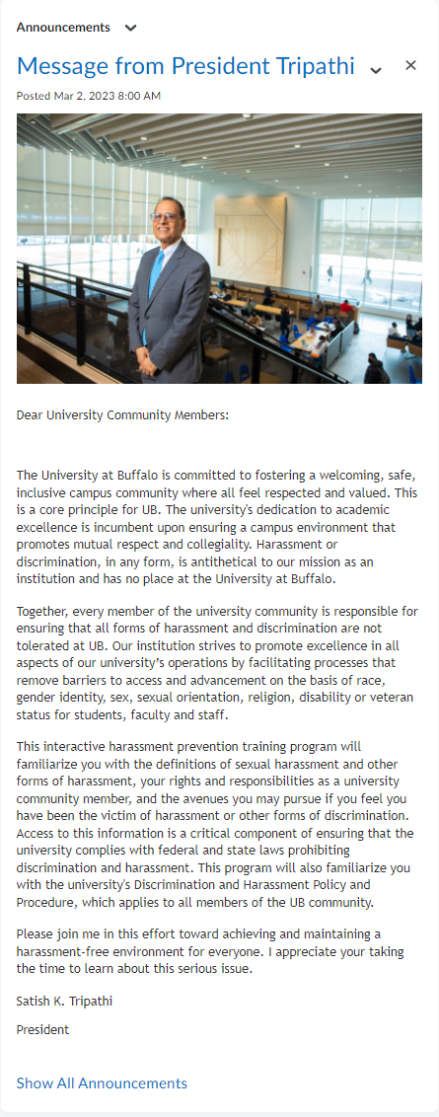
- Read the message from President Tripathi.

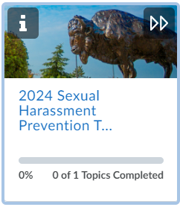
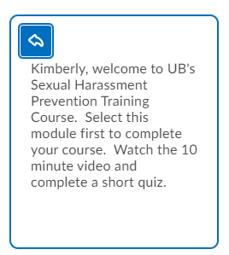
- The Visual Table of Contents Widgets guides you through the course and additional resources available to you outside of the course content. For additional information regarding each Widget:
Select the i on each widget to ‘flip’ the Widget and gain details on the Widget.
The additional Information for each Widget will display:
To flip back to the original view:
Select the Back Arrow in the upper left corner of the tile.

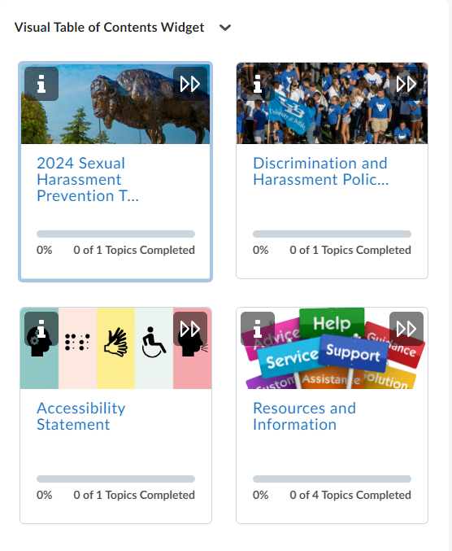
- Select the 2024 Sexual Harassment Prevention Training Course
The course requires you to watch a video, complete a short quiz, and review the Discrimination and Harassment Policy.

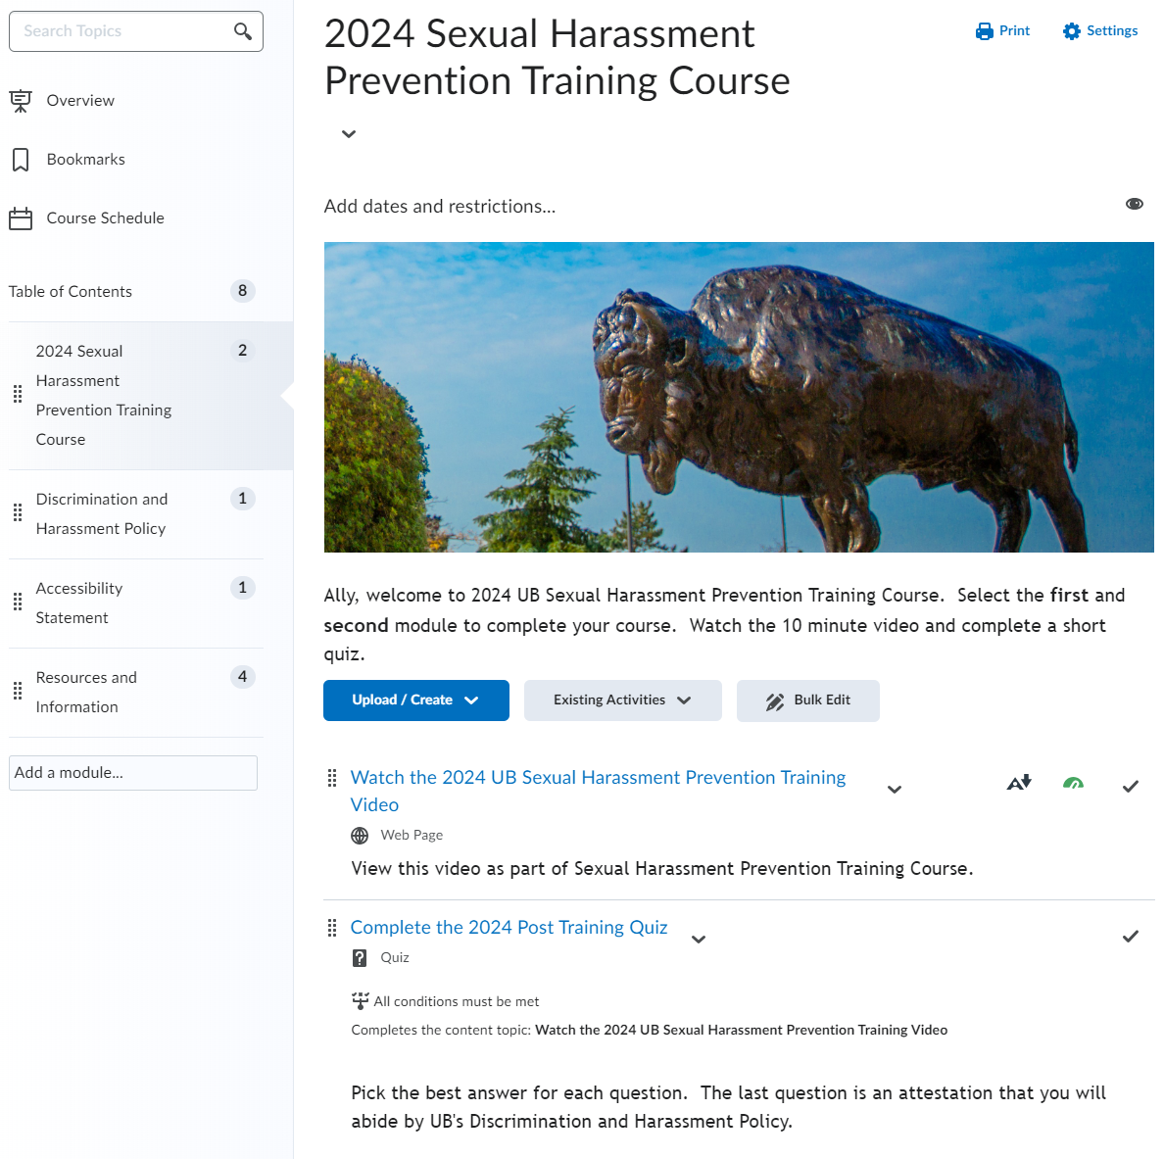
- Select Watch the 2024 UB Sexual Harassment Prevention Training Video.
Quiz: link will appear after watching the video
Video

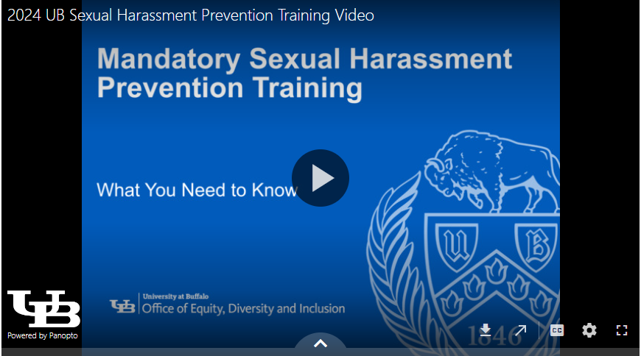
- Play the 2024 UB Sexual Harassment Prevention Training Video
Start the training by selecting the play button in the middle of the screen.
You may choose to watch the video by downloading the video, opening the video in a new window or by making the video full sized.
Panopto is the video platform that was used to create the training video. The software requires your internet browser to accept third-party cookies. The Safari internet browser in particular may require you to change your settings in order to view this type of video file.
If you are using an Apple device (i.e., MacBook, iMac, iPad or iPhone) and the Safari browser, please review the following information regarding Panopto and the Safari internet browser:
How to enable support for Third-Party browsers
Speed of Speaking

Download
Open New
Window
Toggle Captions
Full-Sized Video Window
Alternative Formats and Accessibility Features:
To access Alternative Formats
Select the Alternative Formats link below the video.
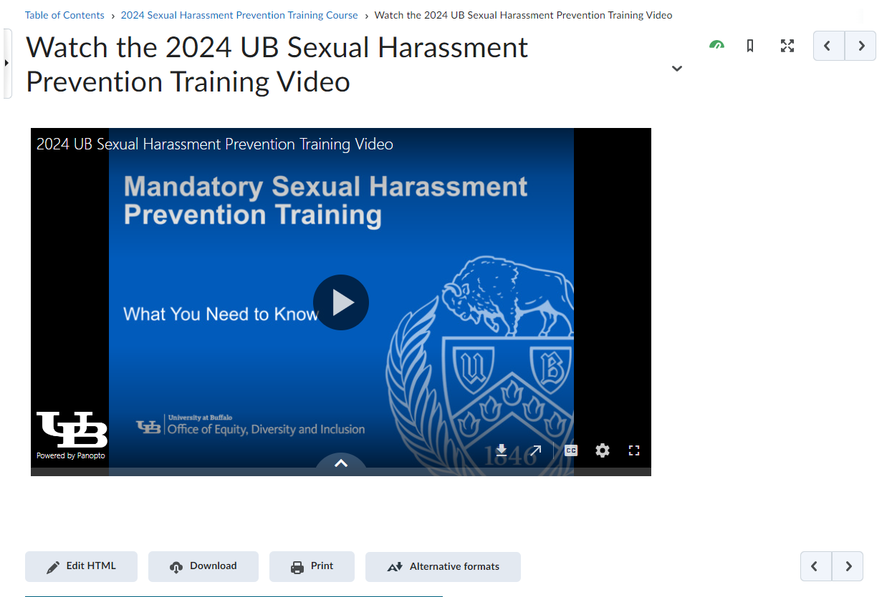
Alternative Formats for the training video
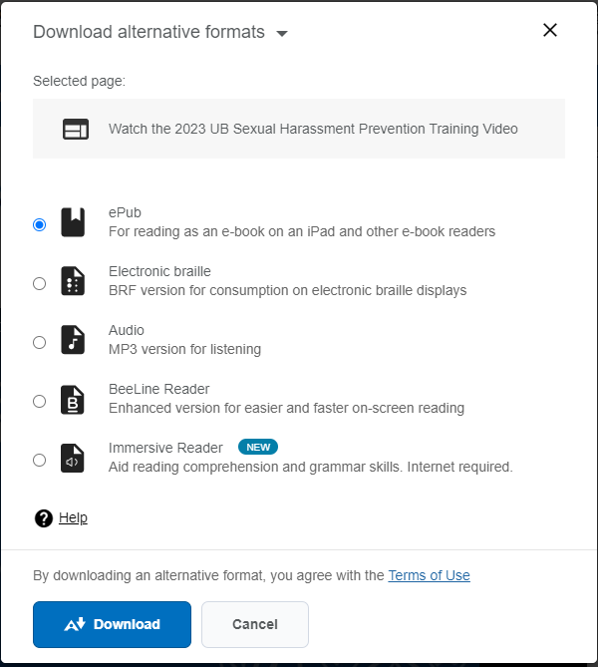
This will bring up the options to select multiple formats to review the training material.
Select the desired format and select Download.
Begin the Quiz:
- Post Training Quiz:
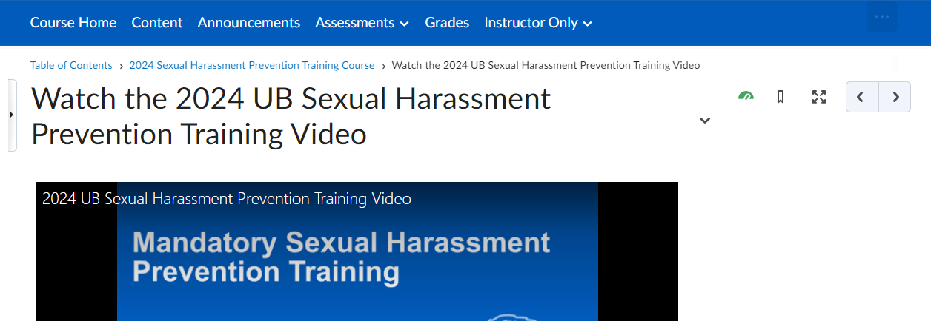
  - Navigation Option I:
To begin the Quiz, Select the right arrow button above the video:
Select Right Arrow

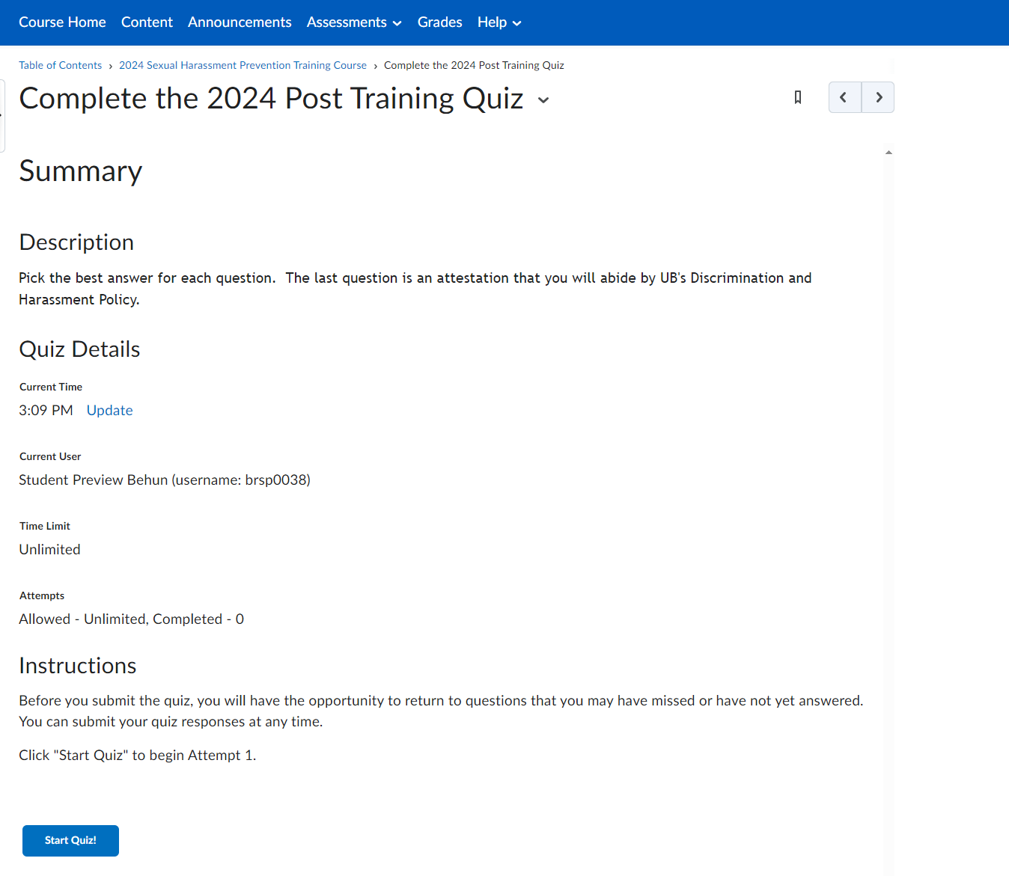
The next page displays:
Select Start Quiz!

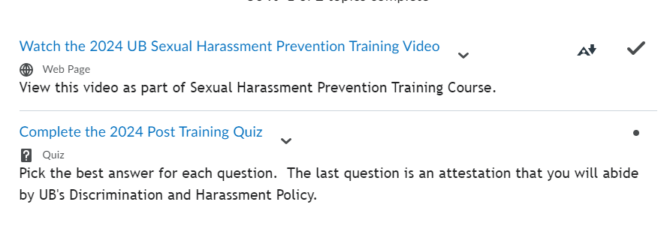
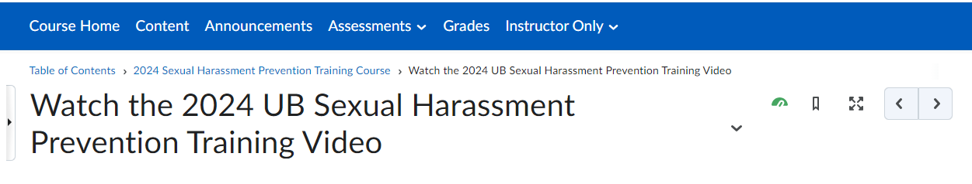
  - Navigation Option II:
Navigate to the 2024 Sexual Harassment Prevention Training Course.
Select the navigation link 2024 Sexual Harassment Prevention Training Course, the breadcrumb navigation, below the horizontal navigation bar.
Select the Complete the 2024 Post Training Quiz link
Select link to begin quiz.
Breadcrumb Link

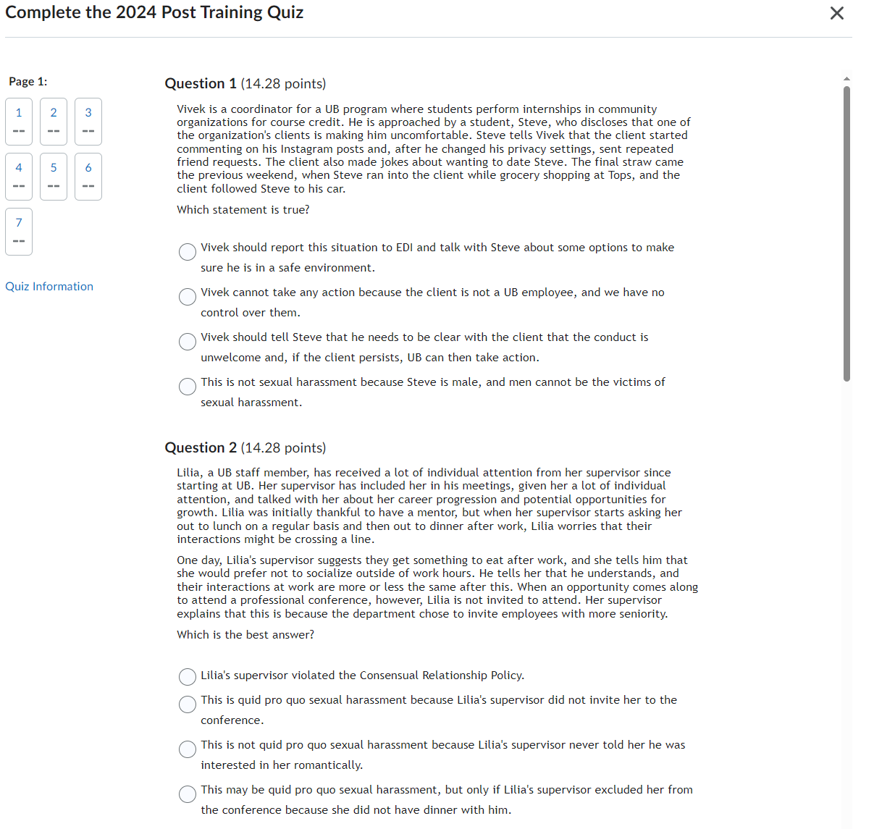
- Complete the Quiz
Status of Quiz Completion

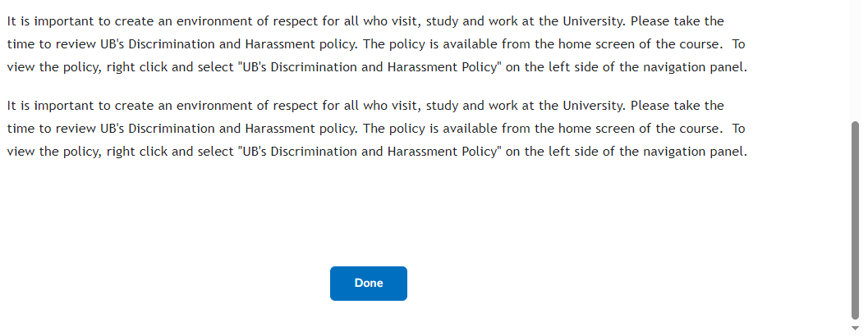
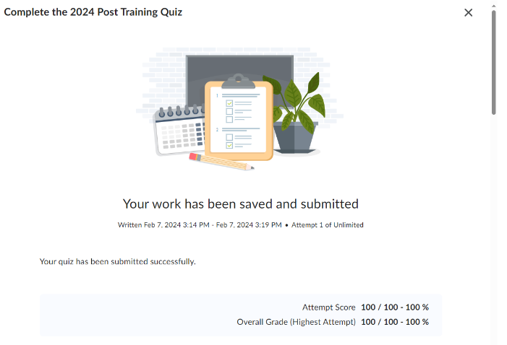
  - Once you answer all the quiz questions, select Submit Quiz, and select Submit Quiz a second time, and the following page will appear:
Scroll to the bottom of the page and
Select Done and you will be taken to the next page.

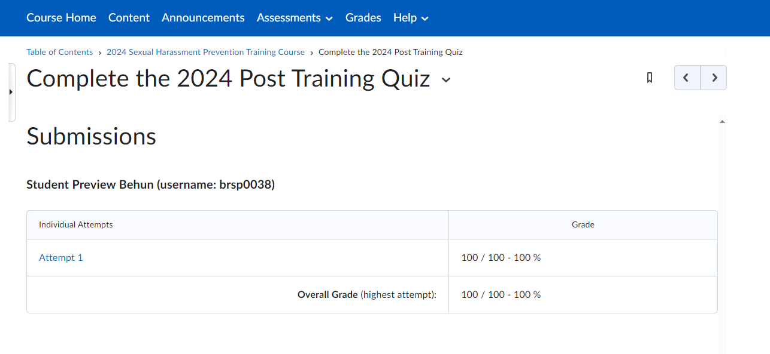
  - You will receive a Post Quiz Summary Page:
Your Name, (username: your UBIT Name)
  - Select the Right Arrow
Your Name, (username: your UBIT Name)

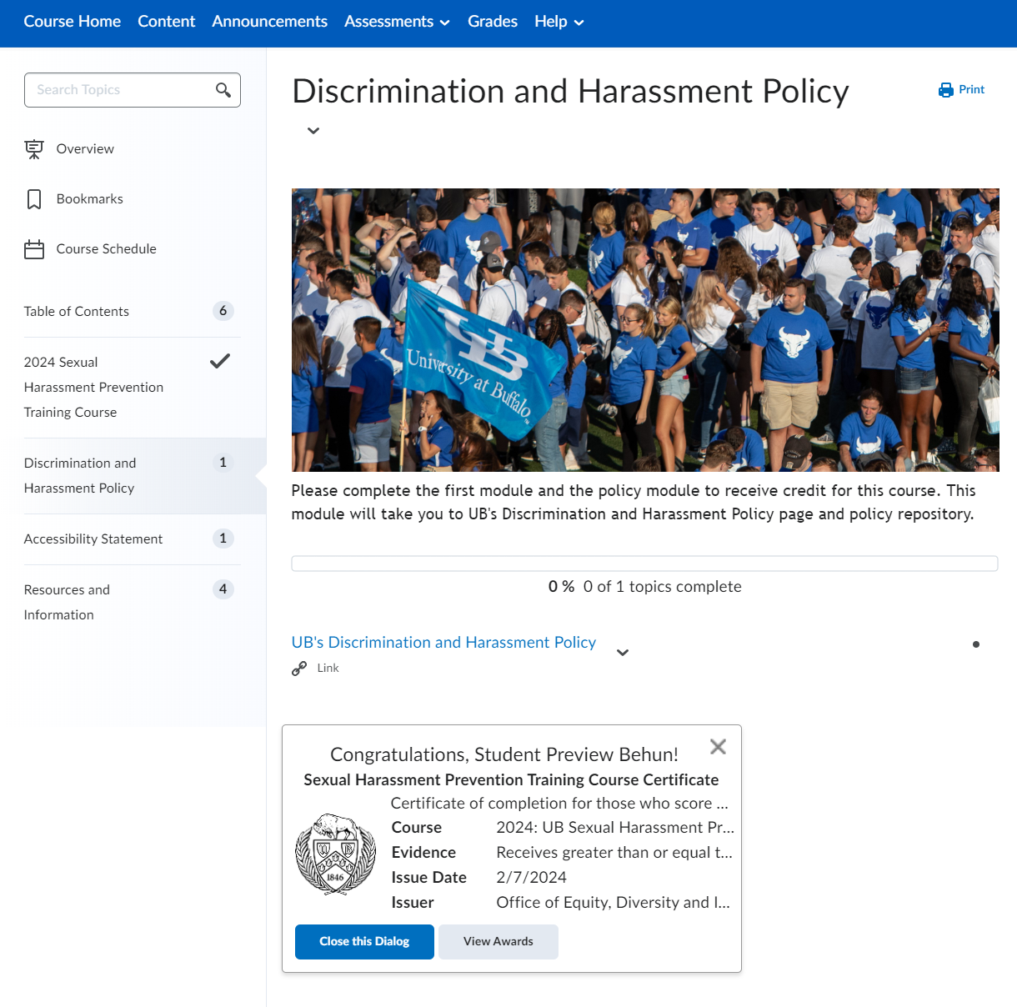
  - You will be taken to the next Table of Contents component and the following pop-up will display if you completed the quiz with a passing grade and selected all the acknowledgements:
Quiz Completion Pop-up
Your Name!

Certificate of Completion
- Viewing Your Awards/Certificate of Completion
Select ‘View Awards’
Your Name!
Select View Awards to create a Certificate!

If you do not receive a pop-up listed above, you may access your certificate by the following:
  - Select the Messaging icon to view the latest updates about the course:
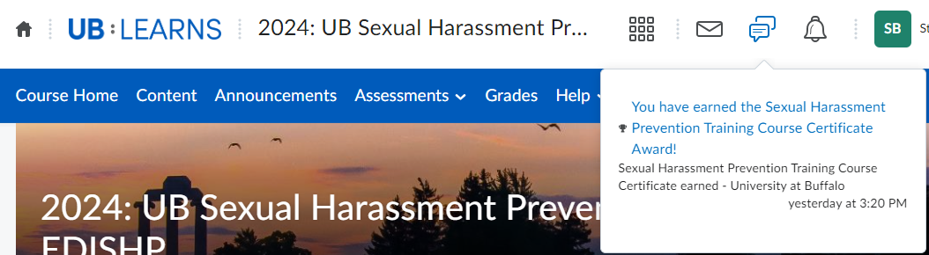
  - Select the Message you would like to view:
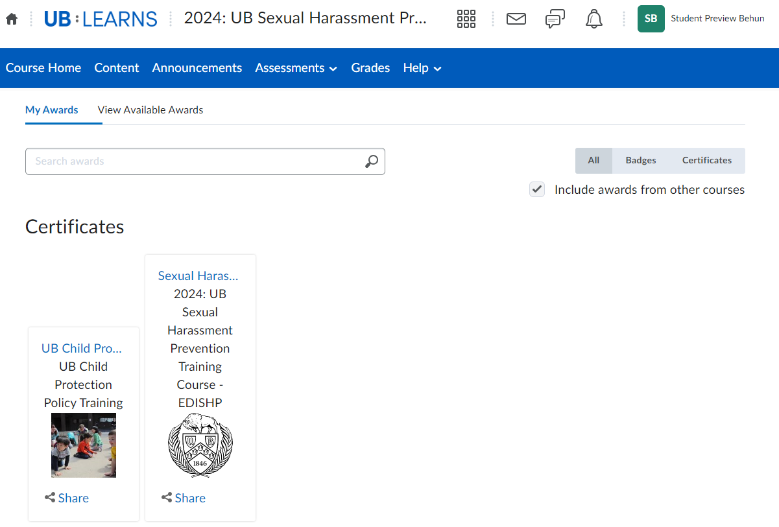
  - You will navigate to the ‘My Awards’ page:
Select the Sexual Harassment link
Select Sexual Harassment Prevention Training Course Certificate
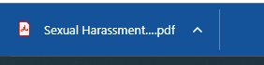
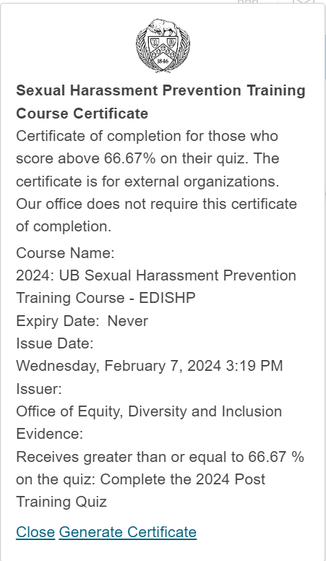
  - The following pop-up will appear:
Select ‘Generate Certificate’ to create a
PDF Certificate of Completion
A PDF will Download to your device.
Go To letter h. to view the certificate.

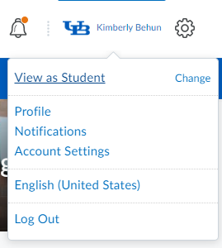
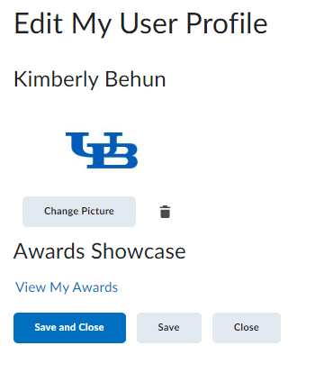
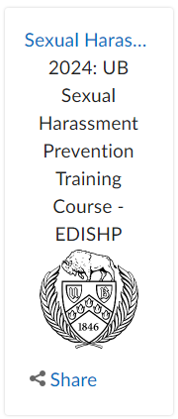
If you do not receive a pop-up, or see a message
in your message area, you may access your
certificate by the following:

  - Select your Profile Name and select Profile:
  - Select View My Awards:
  - Select the Sexual Harassment link
The following pop-up will appear:
Select ‘Generate Certificate’ to create a
PDF Certificate of Completion
A PDF will Download to your device.
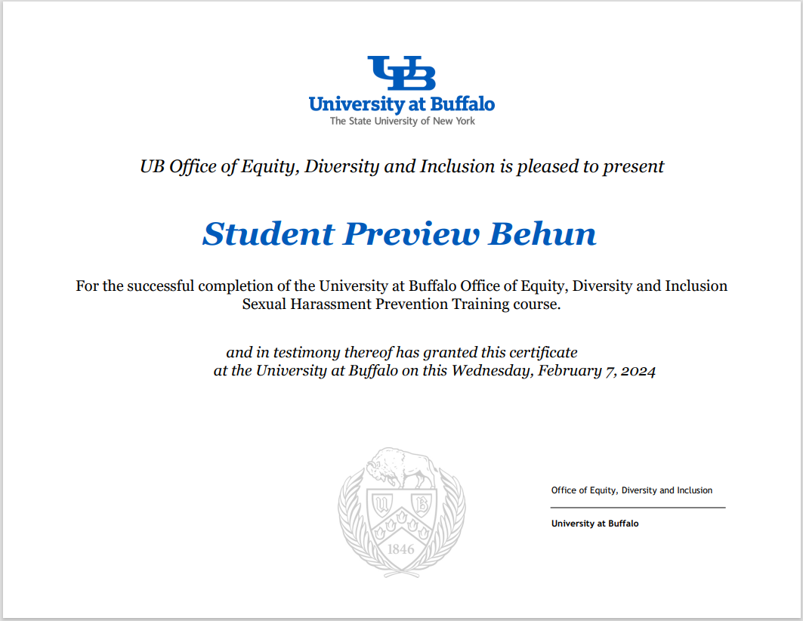
  - To View the Certificate, Open the PDF
Please DO NOT Email EDI with your certificate. We receive your completion information from UB Learns, and this is entered into our official records. Our training liaisons will have access to our official records.
Your certificate is for external organizations who may require your completion.
Your Name
Day, Month Date, Year
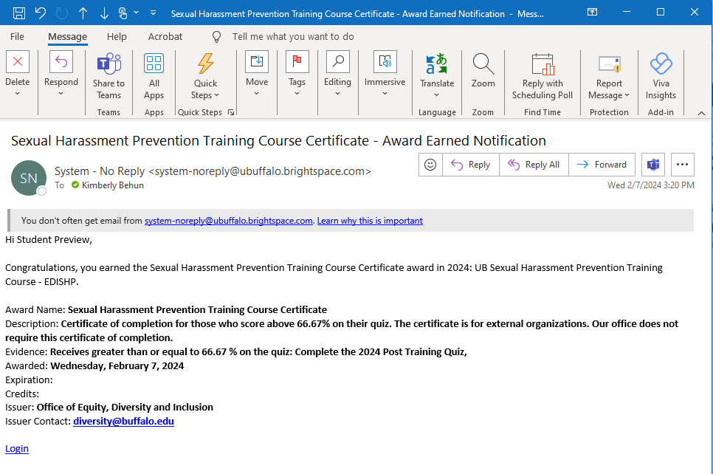
- Course Completion Email
UB Learns Brightspace will email a completion notification to you once you have completed the video and the quiz.
Please DO NOT Email EDI with your Email Notification. We receive your completion information from UB Learns, and this is entered into our official records. Our training liaisons will have access to our official records.
Your Name
Your Name,
- Logout of UB Learns Brightspace
  - Select ‘your name’ in the upper right corner of your UB Learns window.
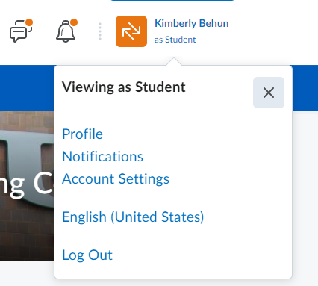
Your Name
  - Select ‘Log Out’
  - Close all internet tabs.

Completing Sexual Harassment Prevention Training on Mobile Phones or Tablets -- Accessing UB Learns from your portable device.
UB Learns is available within the new Learning Management System via the app named Brightspace Pulse. Brightspace Pulse is available through Google Play® or the Apple App Store®. Requirements for mobile phones or tablets are available on the D2L Brightspace Pulse website.

Android Mobile Phone or Tablet:
- Go to the Google Play™ App on your device
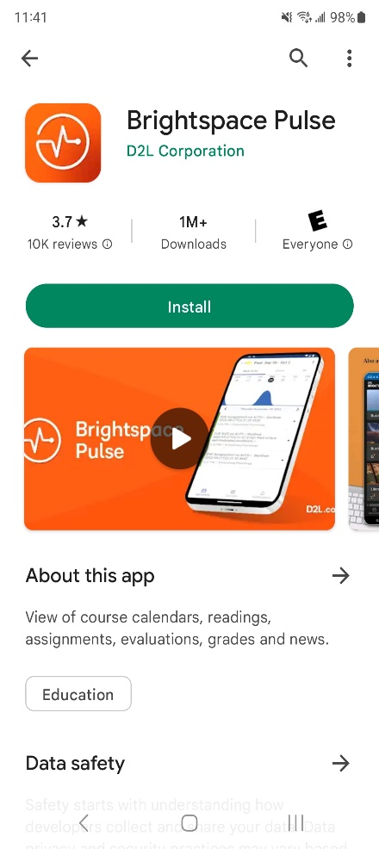
- Search for the Brightspace Pulse app
- Select the Pulse App for Brightspace
and select Install:

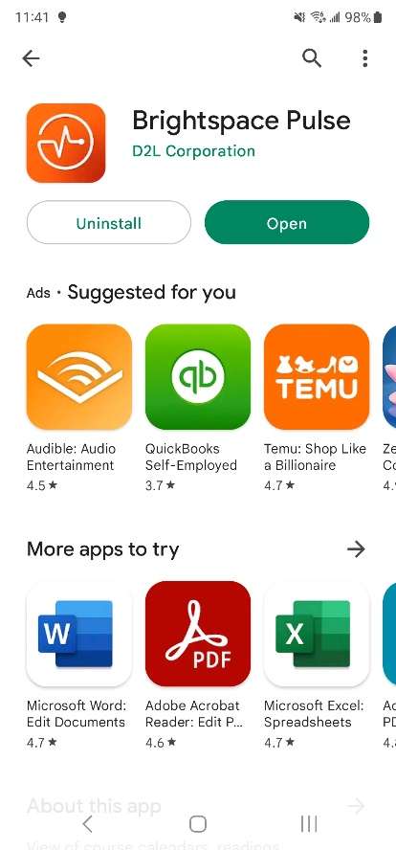
- Brightspace Pulse App will install,
select Open when complete:
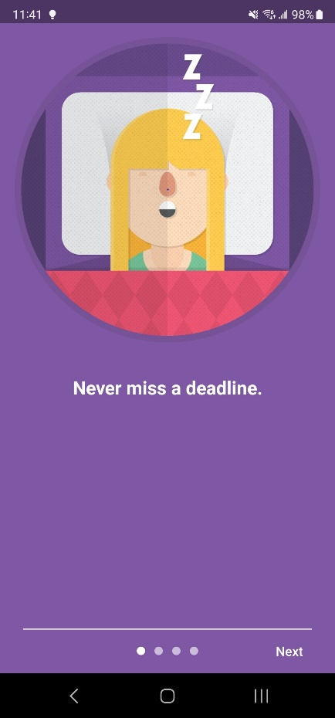
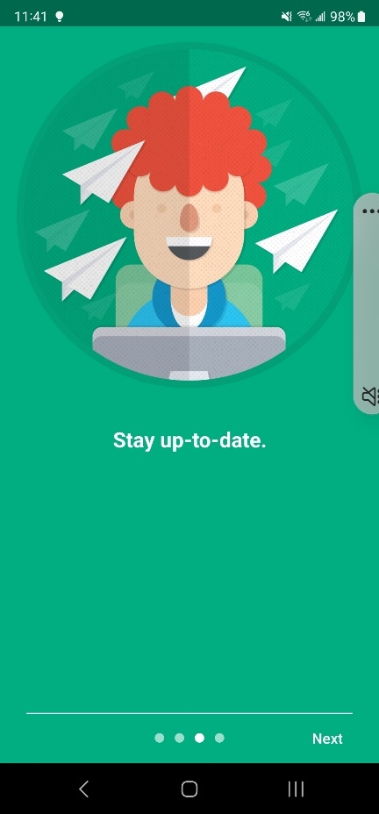
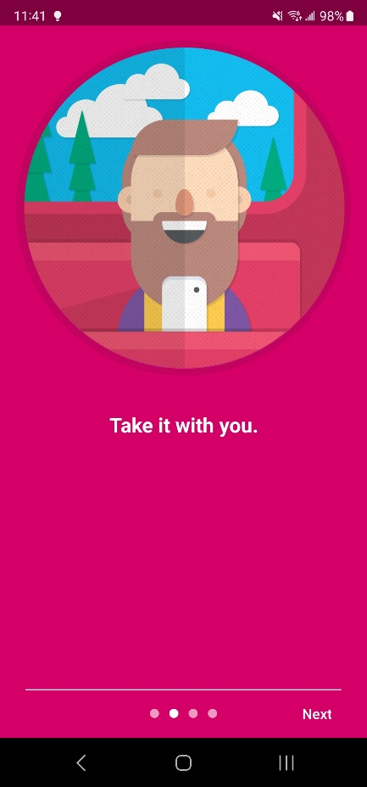
- There are 3 screens to view the Brightspace APP:
Screen 1
Screen 3
Screen 2

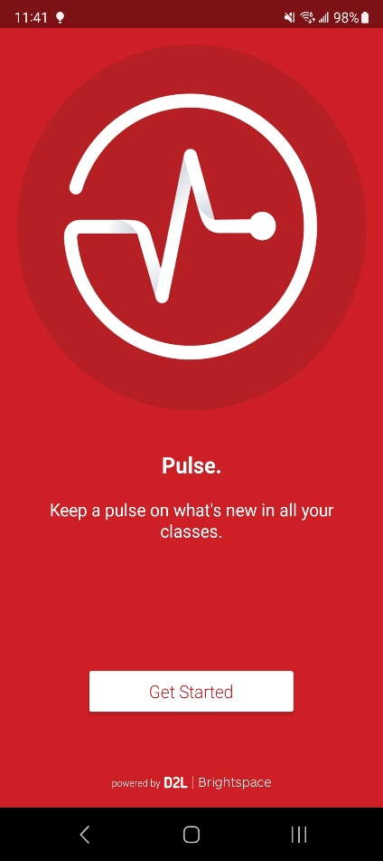
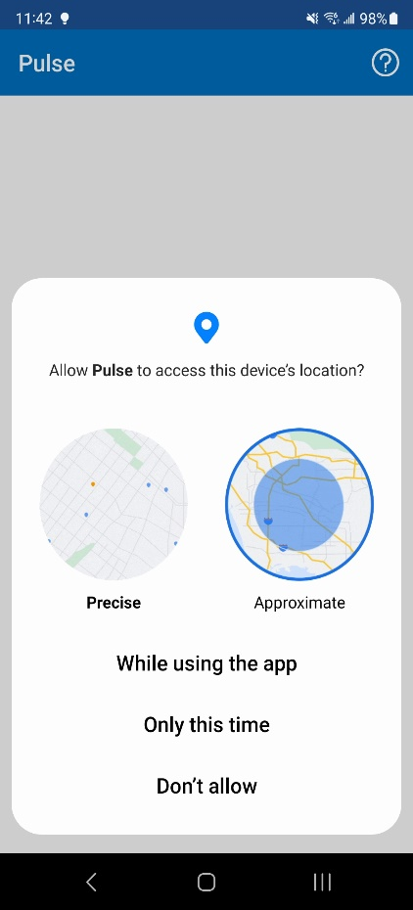
- On the last screen select Get Started:
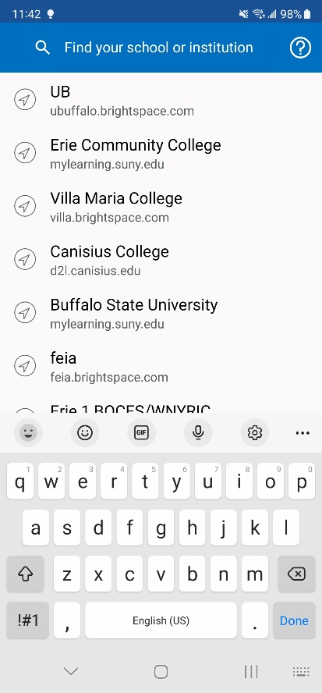
- Select While using the app
to assist in finding the course:
- Search for UB:

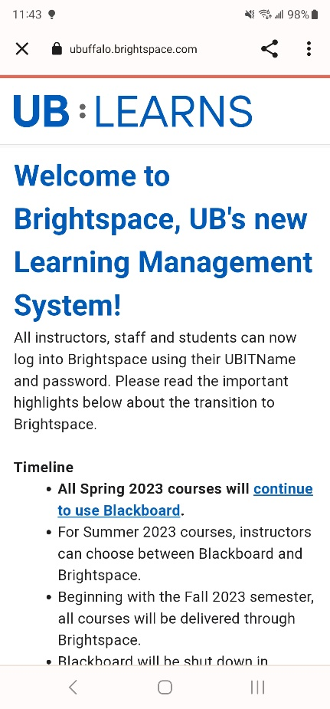
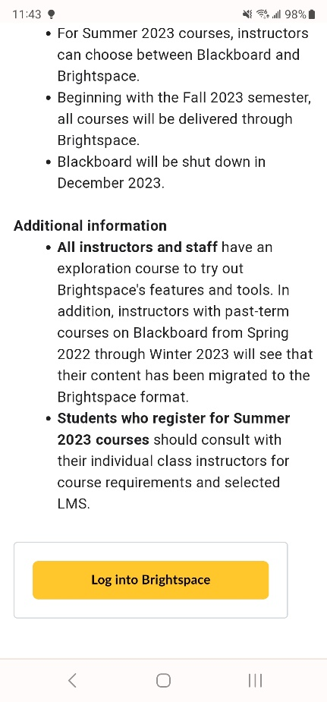
- Welcome to UB Learns:
Scroll down to Select
Log into Brightspace

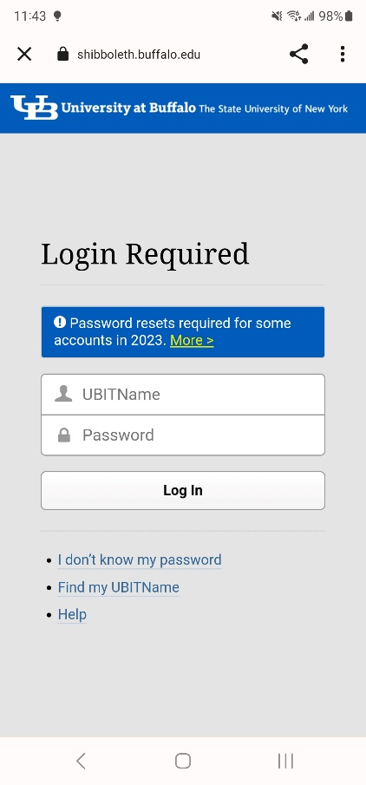
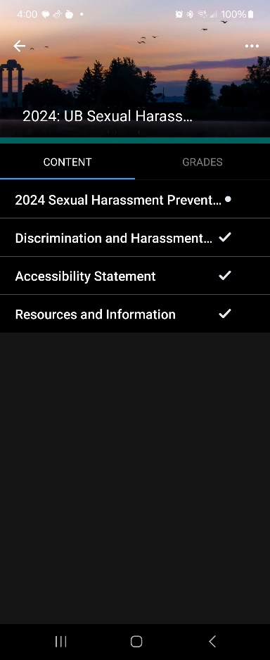
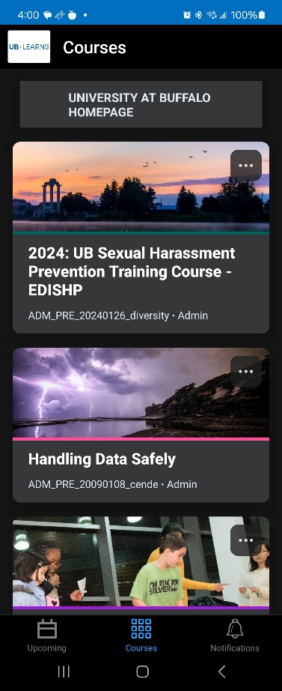
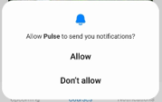
- Enter your UBIT Name,
Your UBIT Password
Select Log In
You may be prompted for your UB Duo Two-Step Verification
- Select either Allow or Don’t allow for
Notifications from the Brightspace Pulse App:
This is a personal choice.
- Begin the course:
  - Select the 2024 Sexual Harassment
Prevention Training Course:
    - Watch the Video
    - Complete the Quiz
    - Select the Discrimination and Harassment
Policy
  - You have completed the course on your Android
device.

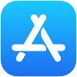
iPhone Mobile Phone or iPad:
- Go to the Apple App Store ® on your device
- Search for the Brightspace Pulse app
- Select the Pulse App for Brightspace
and select Install:

- Brightspace Pulse App will install,
select Open when complete:
- There are 3 screens to view the Brightspace APP:
Screen 1
Screen 3
Screen 2

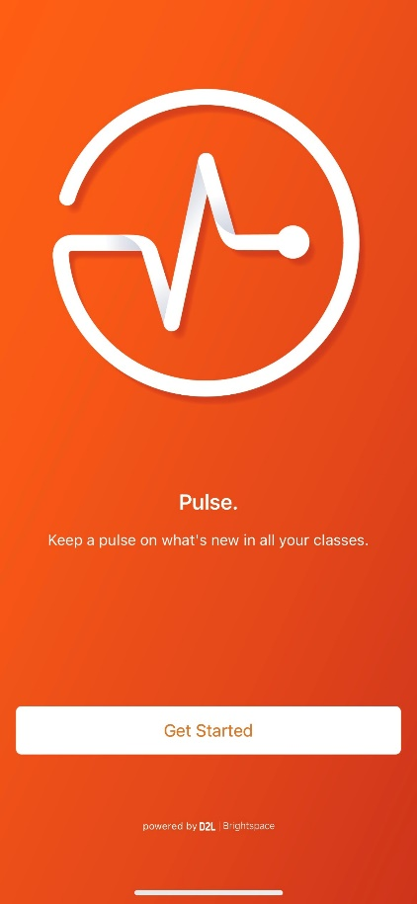
- On the last screen Select Get Started:
- Select While using the app to assist in finding the course:

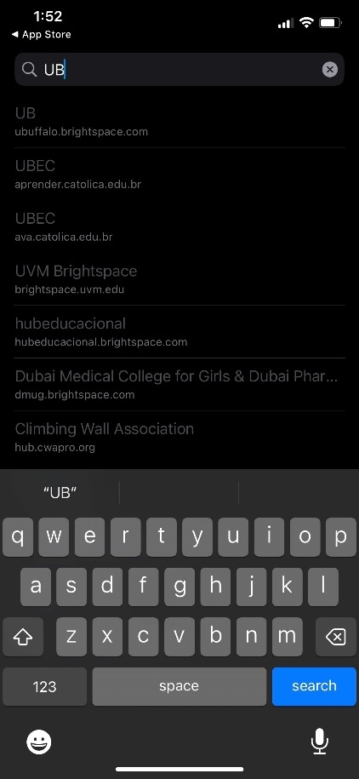
- Search for UB:

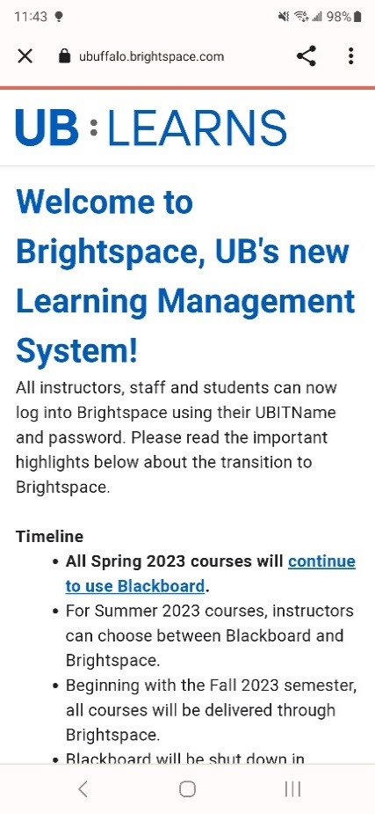
- Welcome to UB Learns:
Scroll down to Select
Log into Brightspace

- Enter your UBIT Name,
Your UBIT Password
Select Log In
You may be prompted for your UB Duo Two-Step Verification

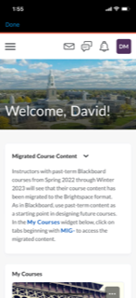
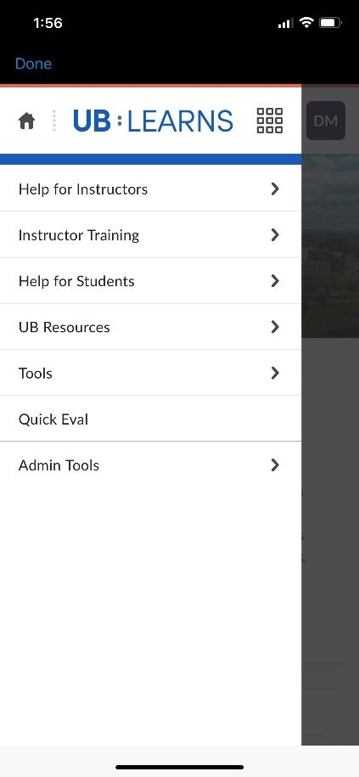
- If the course does not automatically display, you will
need to Discover the course.
  - From the UB Learns home screen
Select the three lines
  - Select Tools:

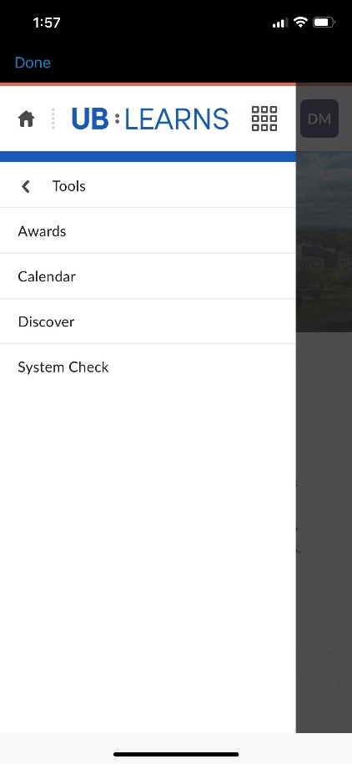
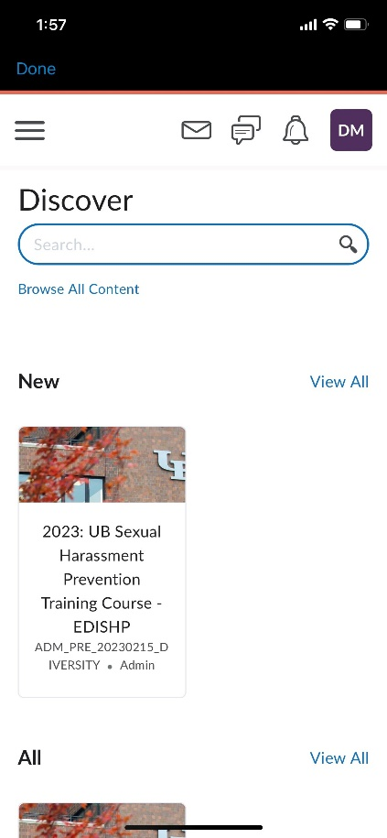
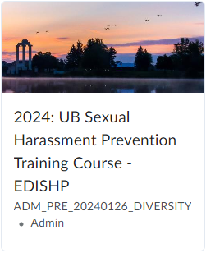
  - Select Discover:
  - In Discover, the 2024 UB Sexual
Harassment Prevention Training
Course will display.
Select the 2024 UB Sexual Harassment
Prevention Training Course.

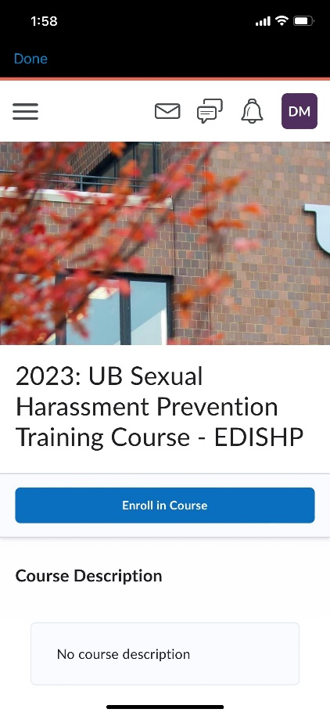
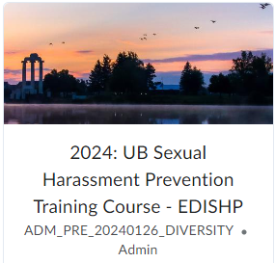
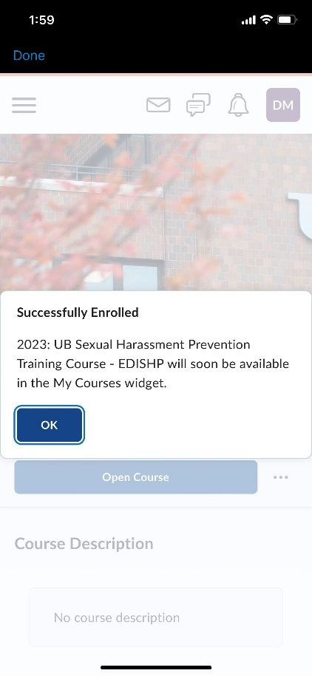
  - Select Enroll in Course
  - Select OK on the Successfully
Enrolled window

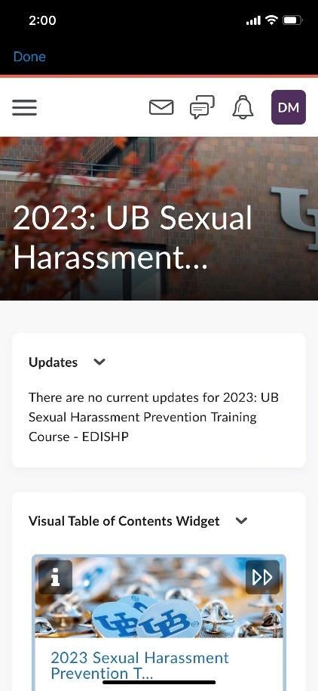
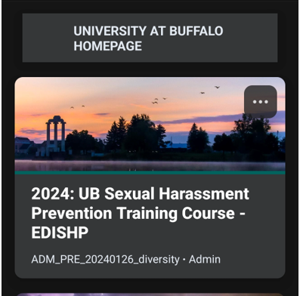
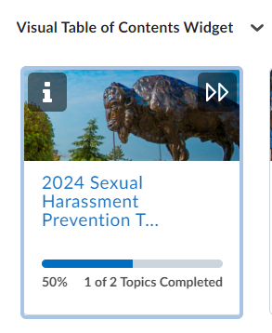
- Begin the course:
  - Select the 2024 Sexual Harassment
Prevention Training Course:
    - Watch the video
    - Complete the quiz
    - Select the Discrimination and Harassment Policy.
- You have completed the course on your Apple Device.

